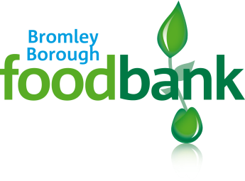 | Bromley Borough Foodbank  c/o Orpington Baptist Church  Station Road  Orpington BR6 0RZ  General Enquiries: 0800 9 20 23 24  info@bromleyborough.foodbank.org.uk
Data Privacy Statement for Promoting Our Work
Personal data
We will use personal information that you share with us if you agree to help us promote our work. This might include photographs and videos. For example, we may use your information in case studies and stories that we publish or share with the media. We will only use your information for this purpose if you have given your consent for us to do so.
What rights do you have?
With regards to this campaign, you have several rights under Data Protection legislation:
- Right to object
You can object if you think we are using your data in the wrong way. If we find we are using your data in the wrong way, we will stop immediately and stop it from happening again.
- Right to have your data corrected
If you think there is a mistake in your data, please tell us. You have a right to have it corrected and we will put right any mistakes as soon as possible.
Finally, if anything happened to your data that could be a risk to you, we will do our best to tell you.

